**3 курс, 13 группа, Мойсейчик Е. С.**

**Лабораторная работа №3_5. Составление отчетов. Транспонирование результирующих множеств.**

**Задания**

1. Развернуть группу строк, информирующую о количестве сотрудников на каждой должности в настоящий момент времени, превращая их значения в столбцы.

SELECT

SUM(CASE WHEN JOBNAME = 'PRESIDENT' THEN 1 ELSE 0 END) AS PRESIDENTS,

SUM(CASE WHEN JOBNAME = 'FINANCIAL DIRECTOR' THEN 1 ELSE 0 END) AS FINANCIAL_DIRECTORS,

SUM(CASE WHEN JOBNAME = 'MANAGER' THEN 1 ELSE 0 END) AS MANAGERS,

SUM(CASE WHEN JOBNAME = 'CLERK' THEN 1 ELSE 0 END) AS CLERKS,

SUM(CASE WHEN JOBNAME = 'DRIVER' THEN 1 ELSE 0 END) AS DRIVERS

FROM CAREER NATURAL JOIN JOB;

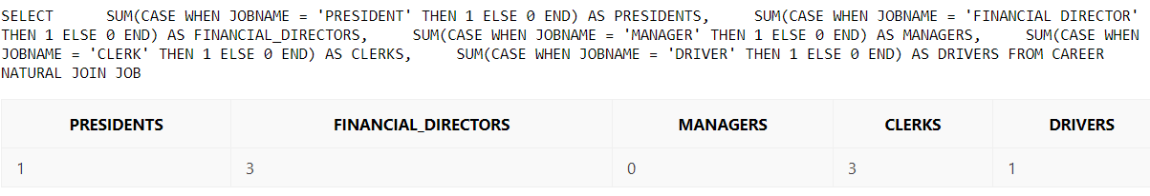

1. Требуется преобразовать строки в столбцы, создавая для каждого значения заданного столбца отдельный столбец.

SELECT

MAX(CASE WHEN DEPTNAME = 'ACCOUNTING' THEN EMPNAME ELSE NULL END) AS ACCOUNTING,

MAX(CASE WHEN DEPTNAME = 'OPERATIONS' THEN EMPNAME ELSE NULL END) AS OPERATIONS,

MAX(CASE WHEN DEPTNAME = 'RESEARCH' THEN EMPNAME ELSE NULL END) AS RESEARCH,

MAX(CASE WHEN DEPTNAME = 'SALES' THEN EMPNAME ELSE NULL END) AS SALES

FROM

(SELECT

d.DEPTNAME,

e.EMPNAME,

ROW_NUMBER()OVER(PARTITION BY DEPTNAME ORDER BY EMPNAME) AS RN

FROM CAREER

NATURAL JOIN DEPT d

NATURAL JOIN EMP e)

GROUP BY RN;

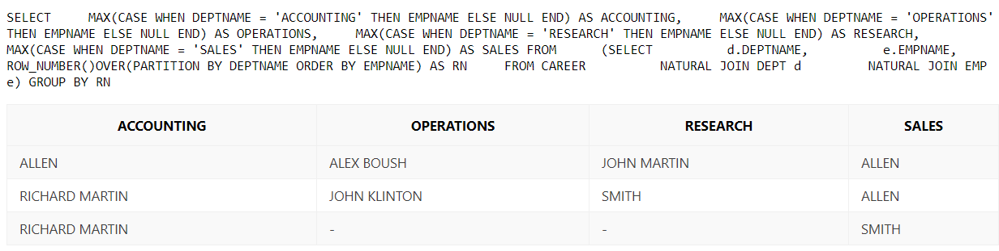

1. Выполните обратное разворачивание для результирующего множества, полученного в задании 1.

CREATE OR REPLACE VIEW jobs_info AS

(SELECT J.JOBNO, J.JOBNAME,

CASE J.JOBNAME

WHEN 'PRESIDENT' THEN EMP_CNTS.PRESIDENTS

WHEN 'FINANCIAL DIRECTOR' THEN EMP_CNTS.FINANCIAL_DIRECTORS

WHEN 'MANAGER' THEN EMP_CNTS.MANAGERS

WHEN 'CLERK' THEN EMP_CNTS.CLERKS

WHEN 'DRIVER' THEN EMP_CNTS.DRIVERS

WHEN 'EXECUTIVE DIRECTOR' THEN EMP_CNTS.EXECUTIVE_DIRECTORS

WHEN 'SALESMAN' THEN EMP_CNTS.SALESMANS

END COUNT_BY_JOB

FROM

(SELECT

SUM(CASE WHEN JOBNAME = 'PRESIDENT' THEN 1 ELSE 0 END) AS PRESIDENTS,

SUM(CASE WHEN JOBNAME = 'FINANCIAL DIRECTOR' THEN 1 ELSE 0 END) AS FINANCIAL_DIRECTORS,

SUM(CASE WHEN JOBNAME = 'MANAGER' THEN 1 ELSE 0 END) AS MANAGERS,

SUM(CASE WHEN JOBNAME = 'CLERK' THEN 1 ELSE 0 END) AS CLERKS,

SUM(CASE WHEN JOBNAME = 'DRIVER' THEN 1 ELSE 0 END) AS DRIVERS,

SUM(CASE WHEN JOBNAME = 'EXECUTIVE DIRECTOR' THEN 1 ELSE 0 END) AS EXECUTIVE_DIRECTORS,

SUM(CASE WHEN JOBNAME = 'SALESMAN' THEN 1 ELSE 0 END) AS SALESMANS

FROM CAREER NATURAL JOIN JOB) EMP_CNTS, (SELECT JOBNO, JOBNAME FROM JOB) J);

SELECT JOBNAME, COUNT_BY_JOB FROM jobs_info;

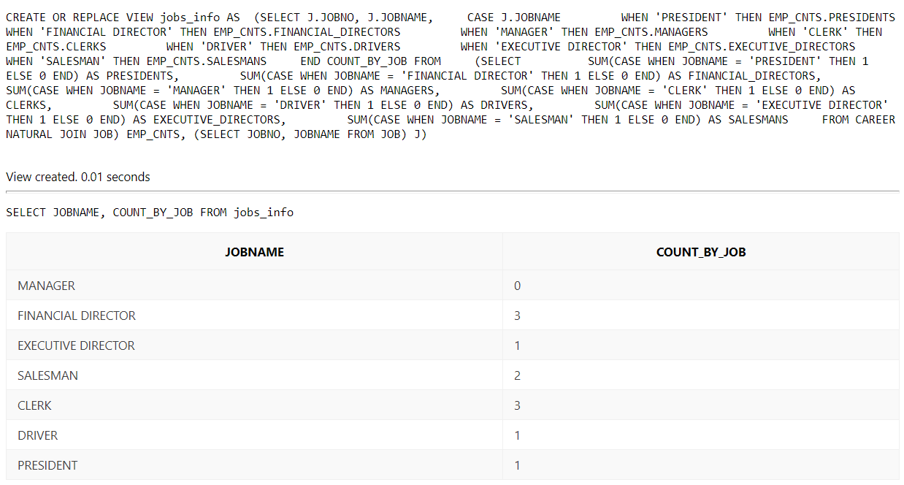

1. Составьте запрос, который будет выполнять обратное разворачивание результирующего множества в один столбец.

SELECT

CASE RN

WHEN 1 THEN JOBNAME

WHEN 2 THEN CAST(COUNT_BY_JOB AS CHAR(2))

END JOBS

FROM

(SELECT * FROM

(SELECT

j.JOBNAME,

j.COUNT_BY_JOB,

ROW_NUMBER() OVER(PARTITION BY j.JOBNO ORDER BY j.JOBNO) AS RN

FROM

jobs_info j,

(SELECT * FROM jobs_info))

WHERE RN < 4);

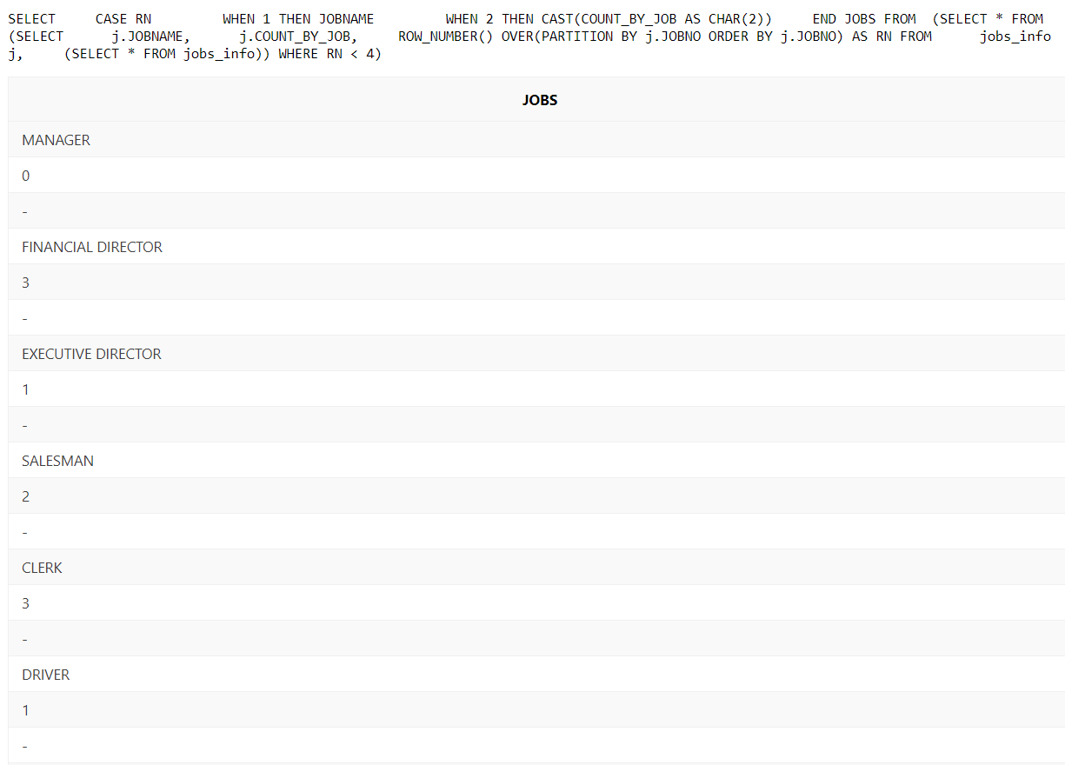

1. Составьте запрос, который будет исключать повторяющиеся значения из результирующего множества.

SELECT

TO_NUMBER(DECODE(LAG(COUNT_BY_JOB) OVER(ORDER BY COUNT_BY_JOB), COUNT_BY_JOB, NULL, COUNT_BY_JOB)) AS EMPS_COUNT_BY_JOB,

JOBNAME

FROM jobs_info;

